**St. Francis Institute of Technology Borivali (West), Mumbai-400103**

**(Autonomous Institute)**

**Department of Information Technology**

**Academic Year: 2024-25**

**Class: TE-ITA/B                                                                            Semester: VI**

**Subject: Web Lab**

**Experiment –8: To Design Feedback Form using Flask.**

1. **Aim:** To learn Flask Framework.
2. **Objectives:** Aim of this experiment is that, the students will be able

* To install Flask Framework
* To understand Basics of Flask.
* To understand Flask Application

1. **Outcomes:** After study of this experiment, the students will be able

* To build applications.
* To build URL
* To understand HTTP methods.

1. **Prerequisite:** Basic understanding of HTML and Python etc
2. **Requirements:** Personal Computer, Windows operating system, VSCode, Python 2.6 or higher, browser, Internet Connection, google doc, latest version of Python.
3. **Pre-Experiment Exercise:**

**Brief Theory:** Refer shared material

1. **Laboratory Exercise**
   * + 1. **Procedure:**

[Install](https://www.python.org/downloads/) [Python 3](https://www.digitalocean.com/community/tutorials/how-to-install-python-3-and-set-up-a-local-programming-environment-on-windows-10) on local machine

Set up a programming environment via the command line

Installactivate Python environment

Install Flask using the [pip](https://pypi.org/project/pip/) package installer

**a. Answer the following:**

## **List What is Web Framework? What is Flask?**

**ANS:**

1. **WEB FRAMEWORK:**

A software tool to build web applications.  
Provides structure for web development.  
Handles routing of web requests.  
Manages sessions and cookies.  
Simplifies database interactions.  
Offers reusable code and templates.  
Supports security practices (like CSRF protection).  
Reduces development time.  
Follows MVC or similar design patterns.

1. **FLASK:**

A micro web framework written in Python.  
Used to create web applications quickly.  
Lightweight with minimal dependencies.  
Offers routing using decorators.  
Built-in development server and debugger.  
Supports Jinja2 templating engine.  
Can be extended with plugins.  
Good for small to medium applications.

## **2. Write and explain Methods of Mail class?**

**ANS:** Methods of Mail Class (Flask-Mail)

1. init_app(app) – Initializes Mail with the Flask app.
2. send(message) – Sends the created email message.
3. connect() – Opens a connection to the mail server
4. send_message() – Creates and sends a message directly.
5. state – Returns current internal state of Mail.
6. Message() – Used to create a new email message.
7. message.body – Sets plain text email body.
8. message.html – Sets HTML content for rich email.
9. message.sender – Defines the sender’s email.
10. message.recipients – Specifies recipient email addresses.

**b**. **Attach screenshots:**

* Flask SS

1. **Post-Experiments Exercise**
2. **Extended Theory:**

Nil

1. **Questions:**

### Why is Flask called a Microframework?

### What is the difference between Django and Flask?

1. **Conclusion:**

* Write what was performed in the experiment.
* Write the significance of the topic studied in the experiment.

1. **References:**

# Flask Web Development[,](https://freepdf-books.com/beginning-javascript-with-dom-scripting-and-ajax-2nd-edition-pdf-free-download/) by Miguel Grinber

This is the feedback form designed using Flask.

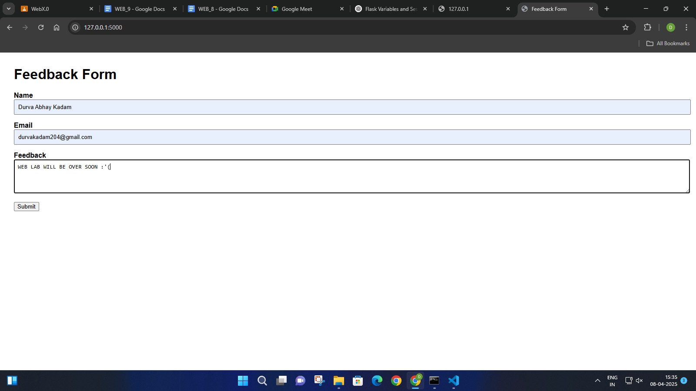

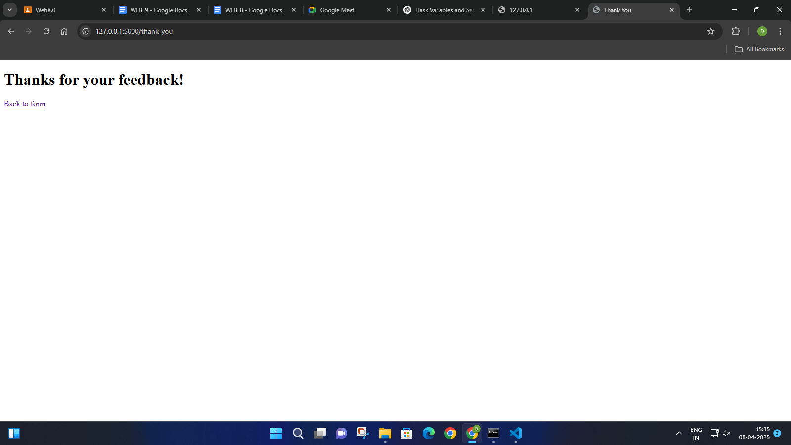

It successfully received the feedback.